**CALTECH Full Stack Java Developer Capstone Project  
SANDEEP KUMAR JAKKARAJU**

*A Food Delivery Website -- Foody !!*  
Project Objective:  
Create a dynamic and responsive online food delivery web application for ordering food items of different cuisines from a restaurant.  
  
Contains an Admin and an User portal.  
When you login with Admin user you will be redirected to Admin Portal.  
When you login with Non-Admin user you will be redirected to the End User Portal.  
  
Admin Portal Features:  
1. Signup/Sign In  
2. Add and Remove Cuisines   
3. Add and Remove Food Items For a Cuisine   
4. Edit Food Items  
5. Change Password  
6. Logout

User Portal Features:  
1. Signup/Sign In  
2. Search food items based on keywords  
3. Apply Filters on Search Results.  
4. Add selected items to cart and customise order.  
5. Pay for the order and receive an order summary.  
6. Change Password and Logout.

=================================================================================

GIT REPOSITORY: <https://github.com/sandycaltechpgp/capstone-project>

=================================================================================  
TECH STACK:

Java 8, Spring boot, JPA, Hibernate, MySQL, Docker, AWS, Angular 8, HTML, JS, Jenkins, Maven, GIT, GITHUB, H2 Database.

=================================================================================

=================================================================================  
DATA MODEL DIAGRAM:

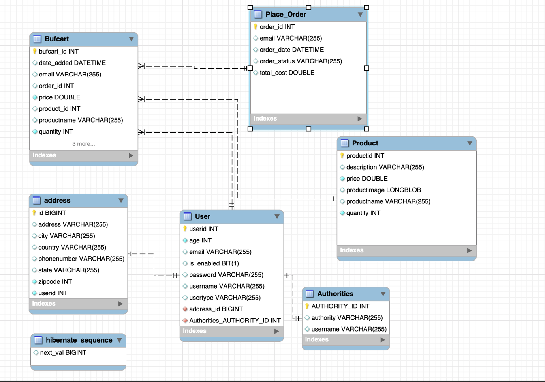

=================================================================================  
UML CLASS DIAGRAM: DOMAIN MODEL

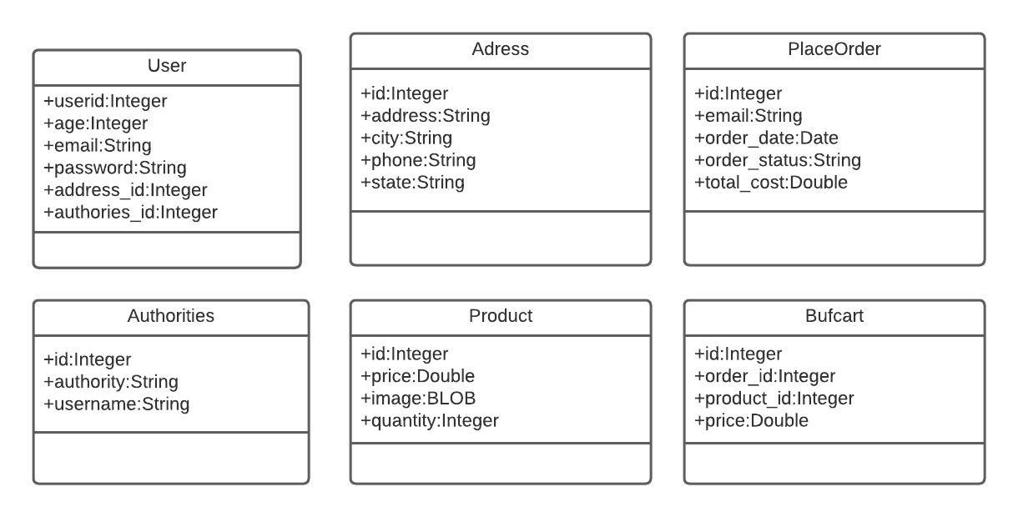

MASTER LIST OF FOOD CATEGORIES/CUISINES

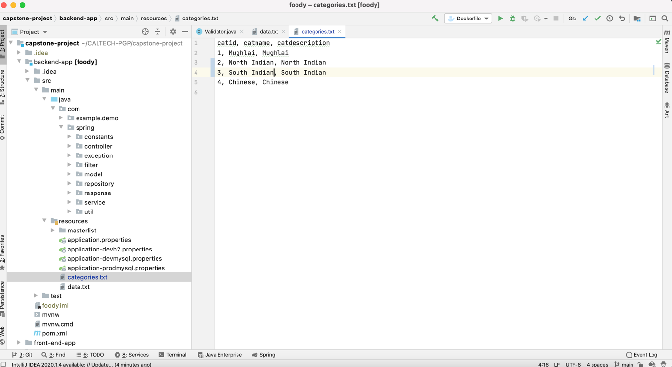

MASTER LIST OF FOOD ITEMS

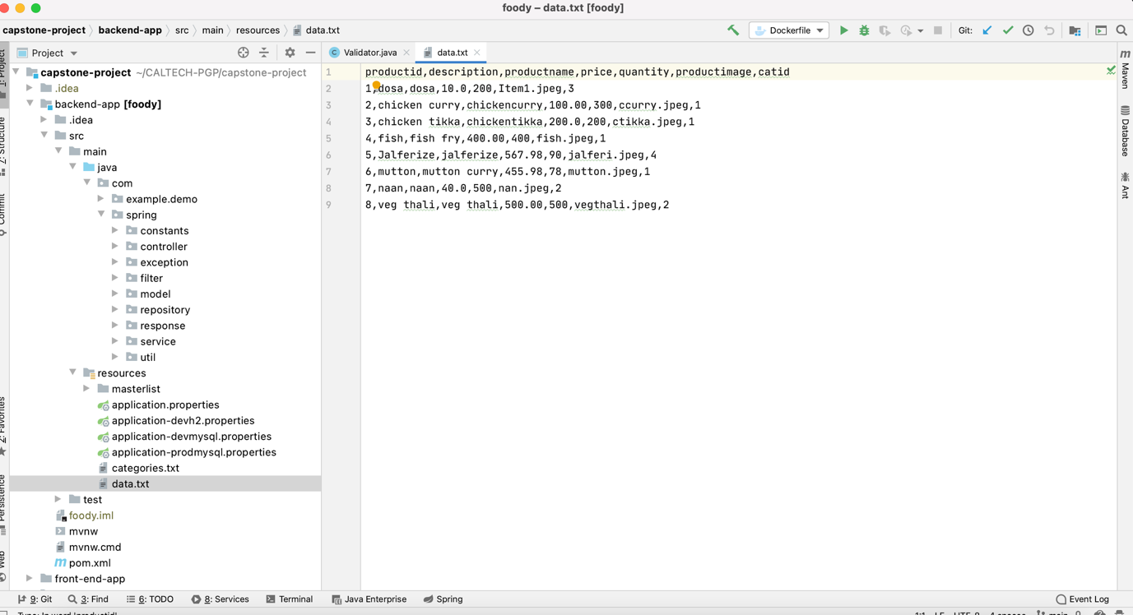

MASTER LIST OF FOOD ITEMS -IMAGES

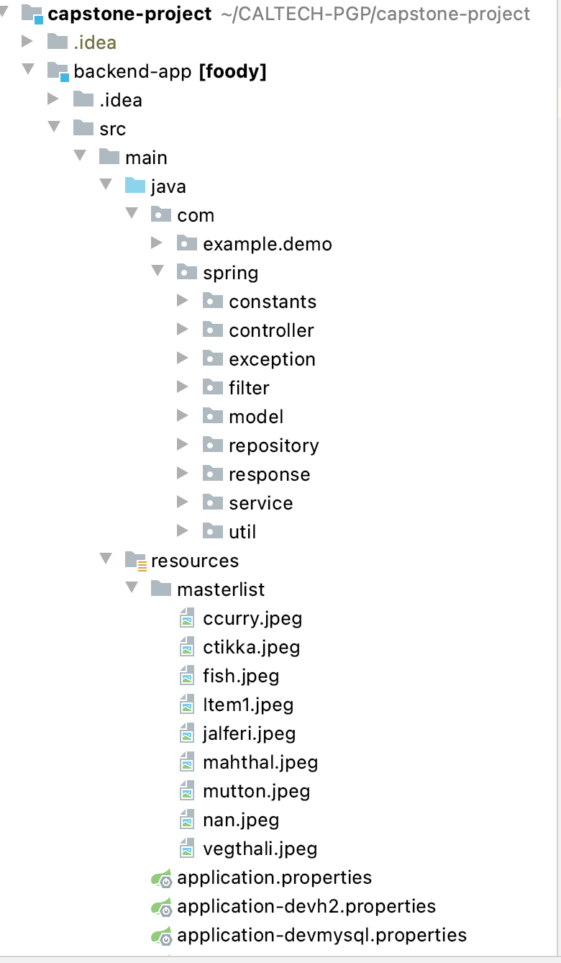

Spring Profiles:

1. devh2
2. devmysql
3. prodmysql

REGISTRATION PAGE: ( BOTH USER AND ADMIN CAN REGISTER HERE )

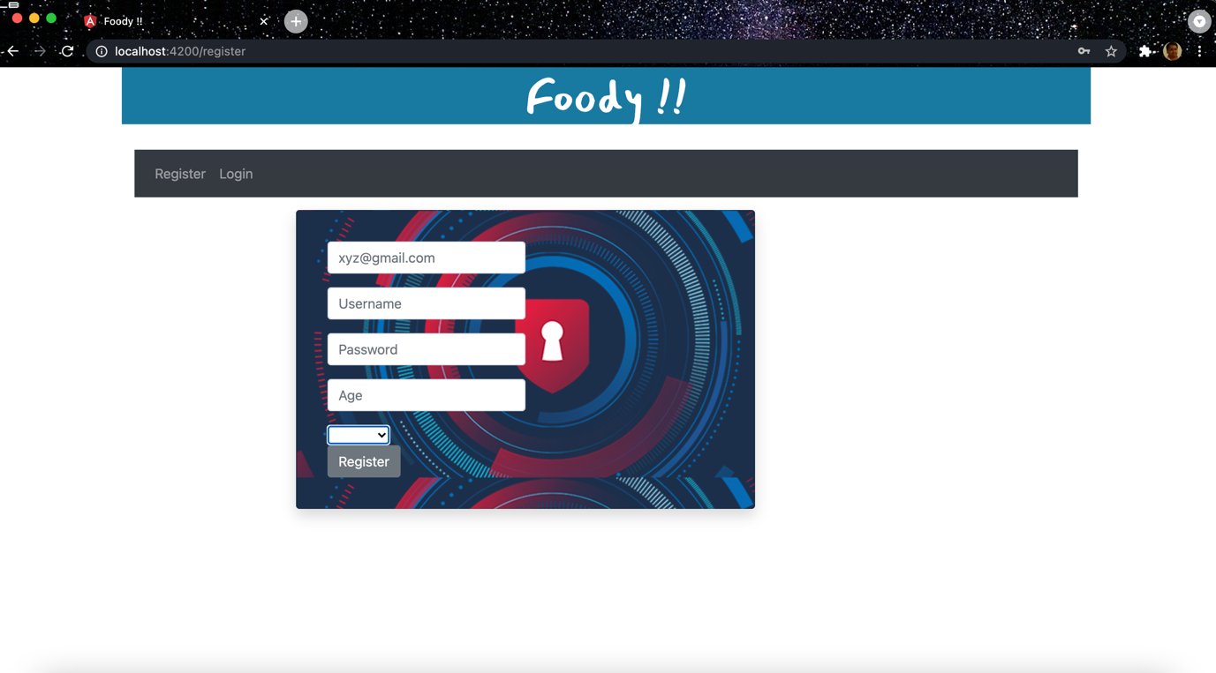

CHOOSE – ADMIN/USER

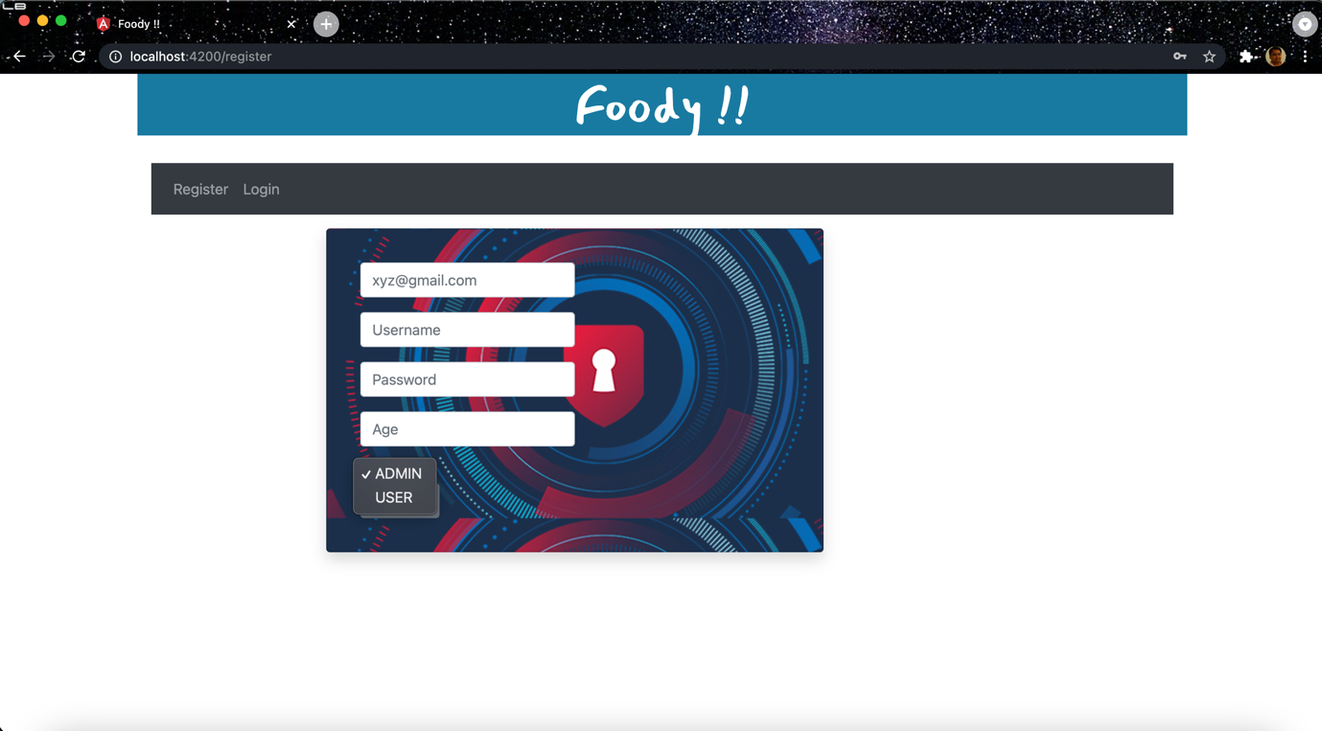

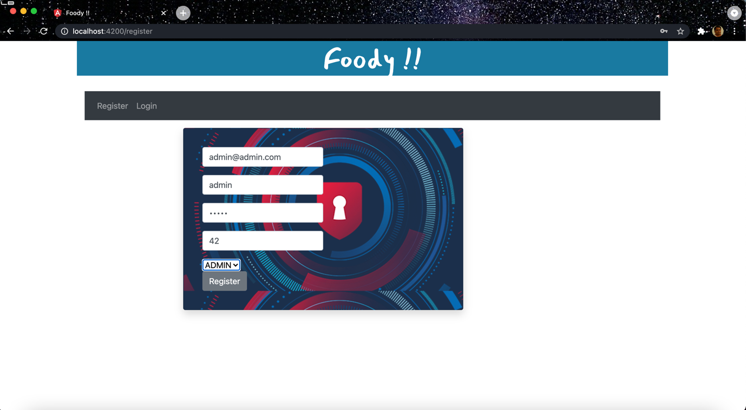

LOGIN : ADMIN

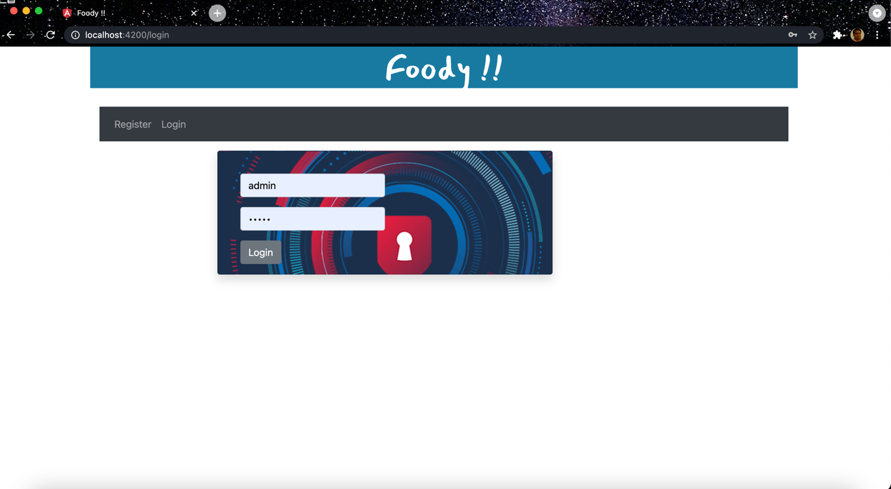

LANDING PAGE FOR ADMIN USER:

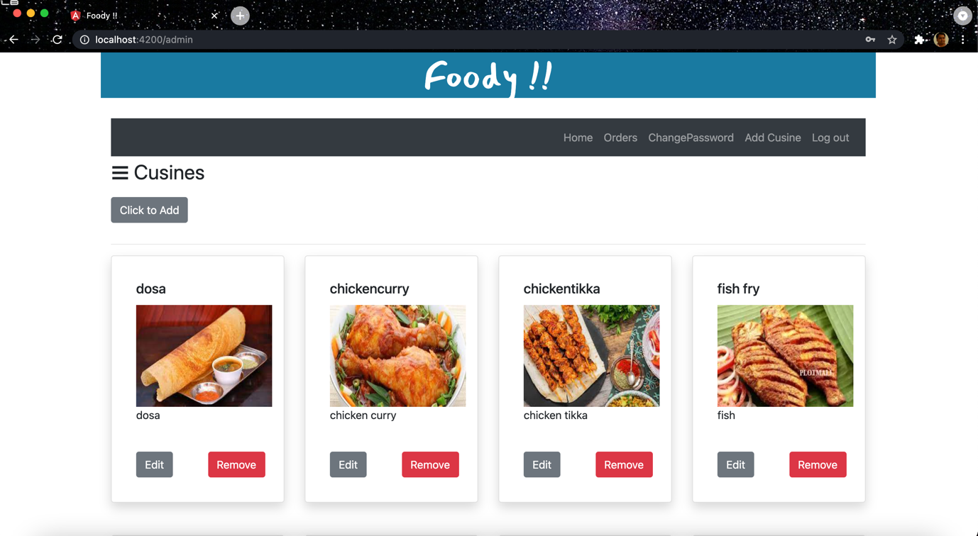

SIDE MENU TO FILTER BY CUISINE:

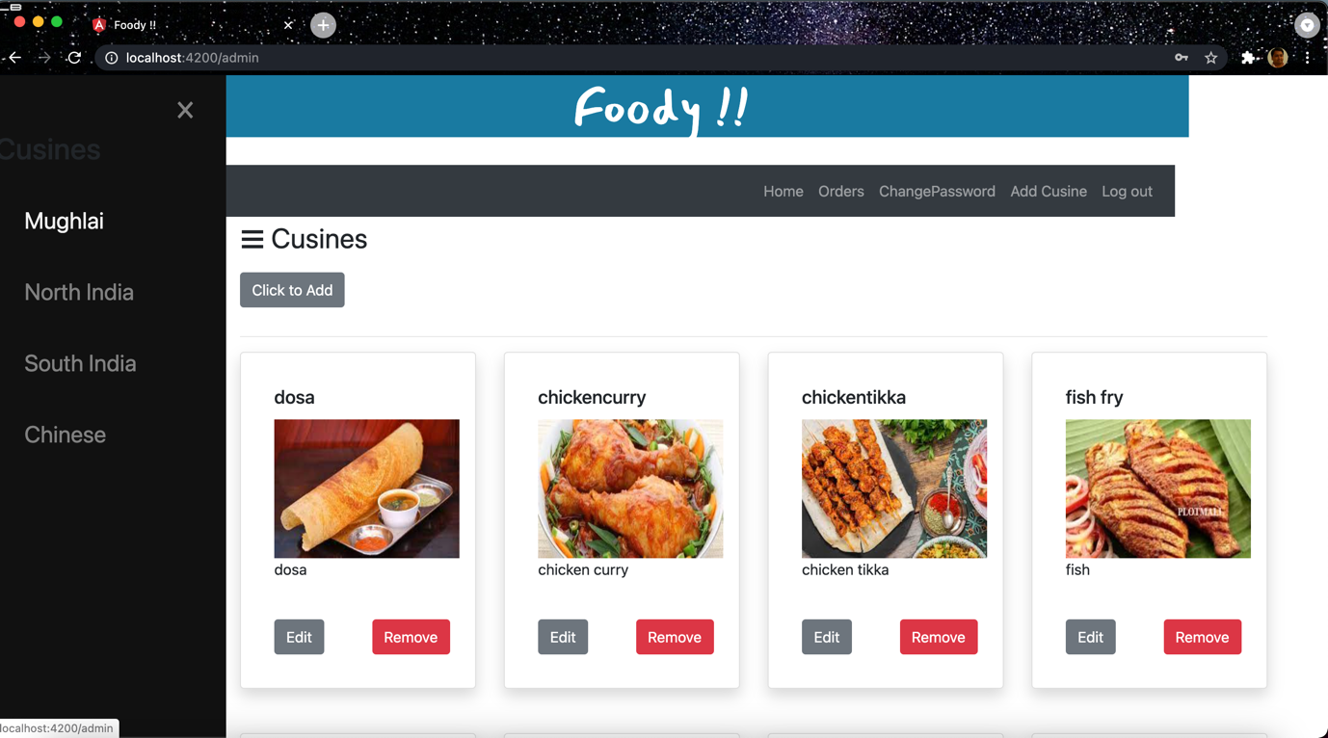

FILTER BY CUISINE:

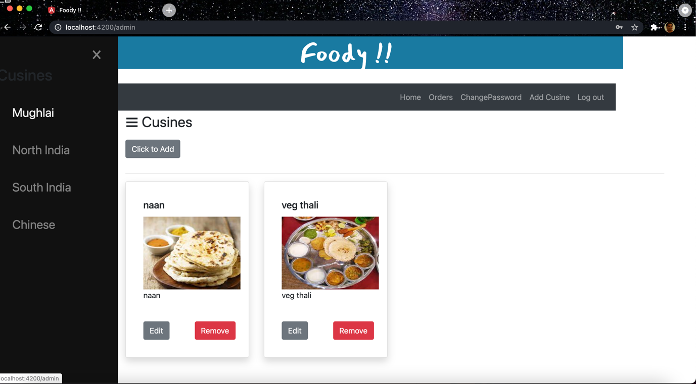

ADD FOOD ITEMS - ADMIN

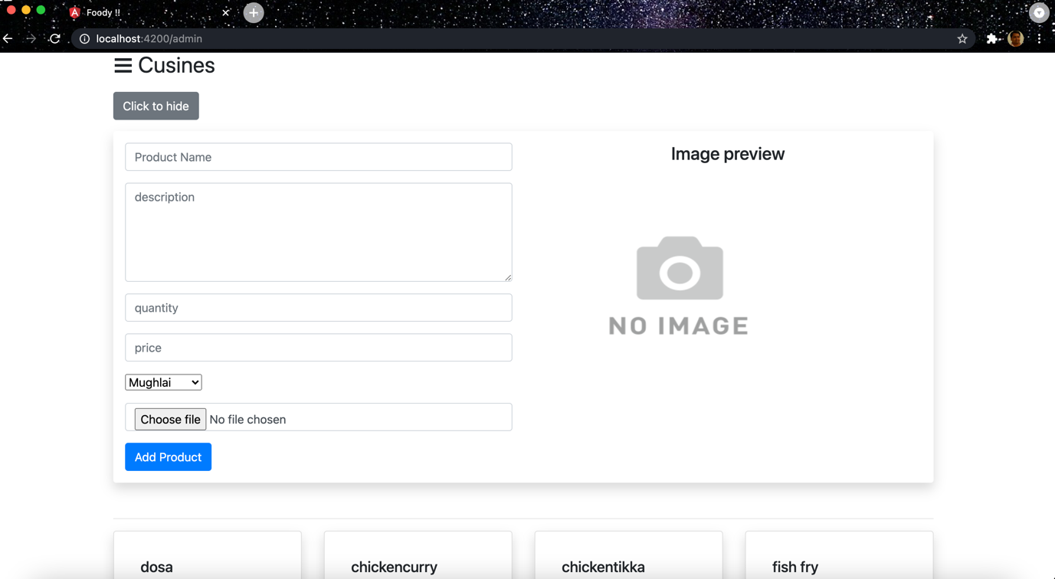

DEMO OF ADD FOOD ITEM WITH CUISINE:

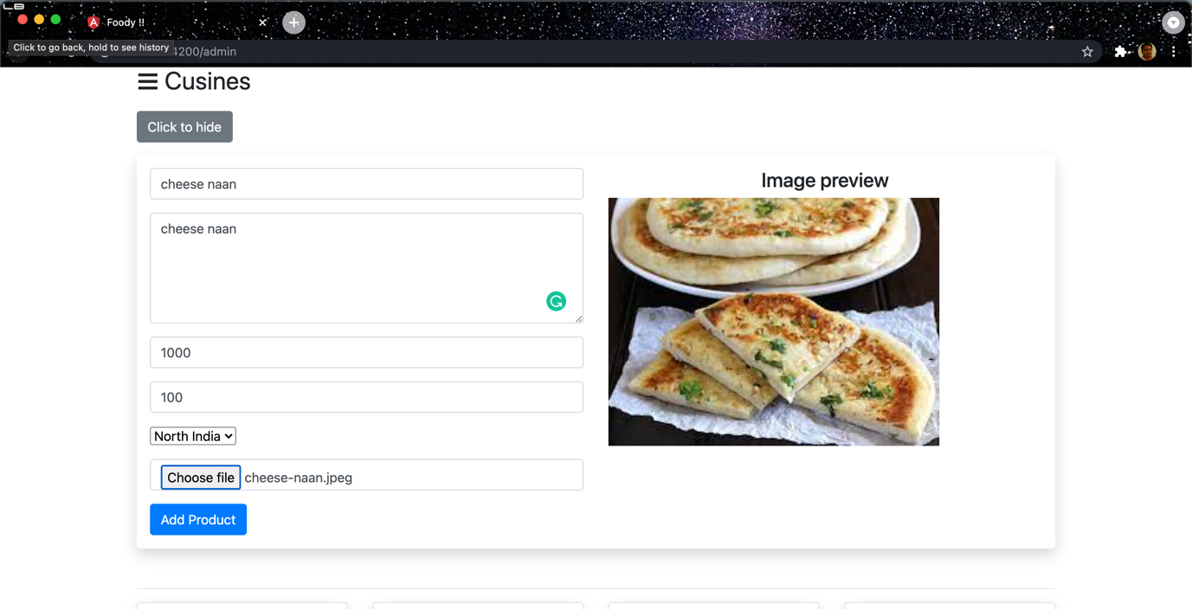

COME BACK TO LANDING PAGE OF ADMIN:

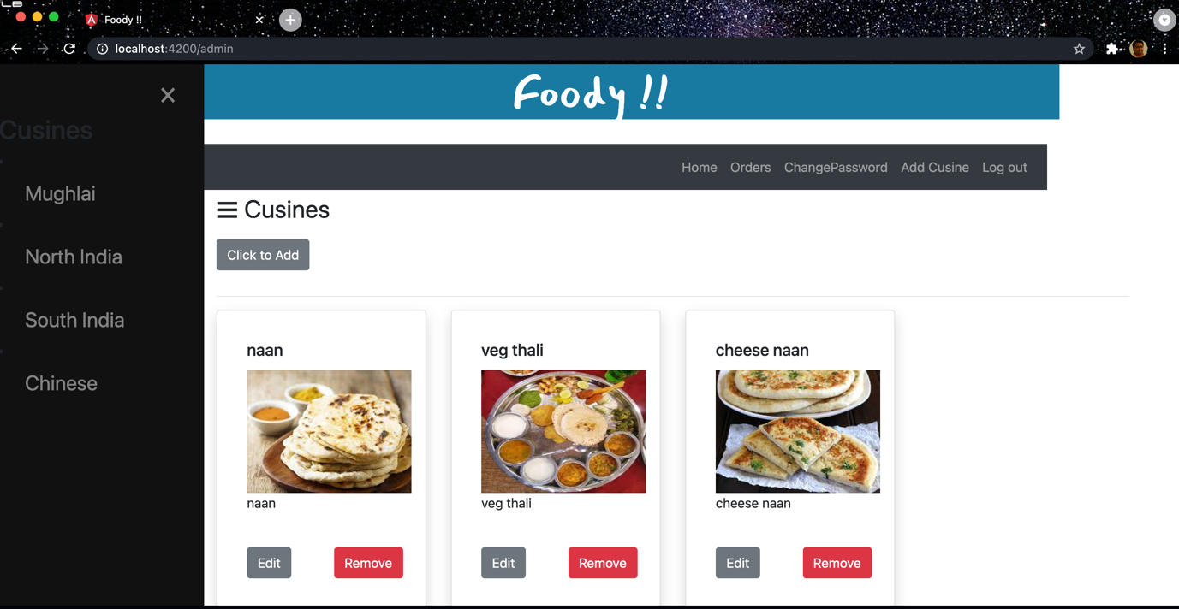

CHANGE PASSWORD - ADMIN

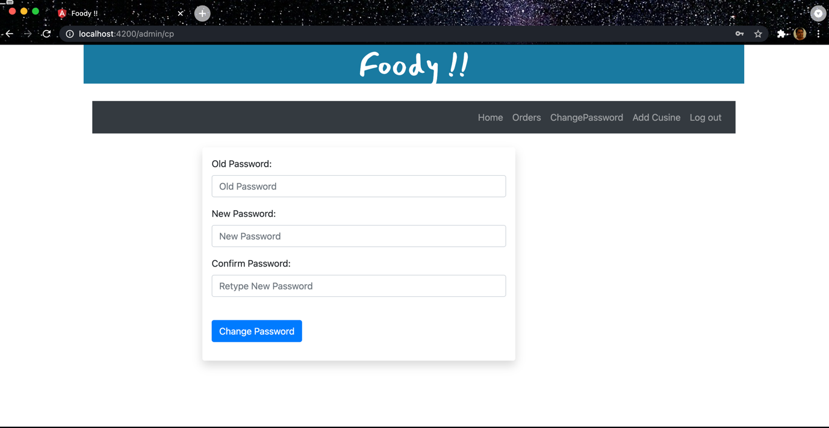

ADD CUISINE:

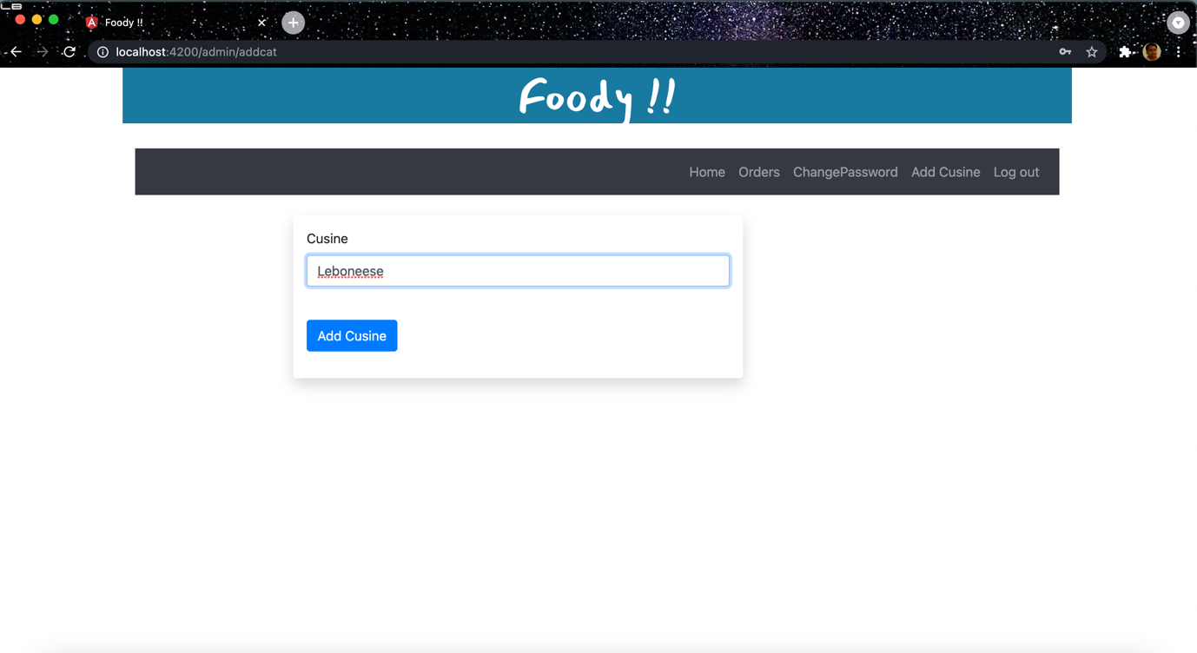

SEE THE NEW CUISINE IN LEFT MENU:

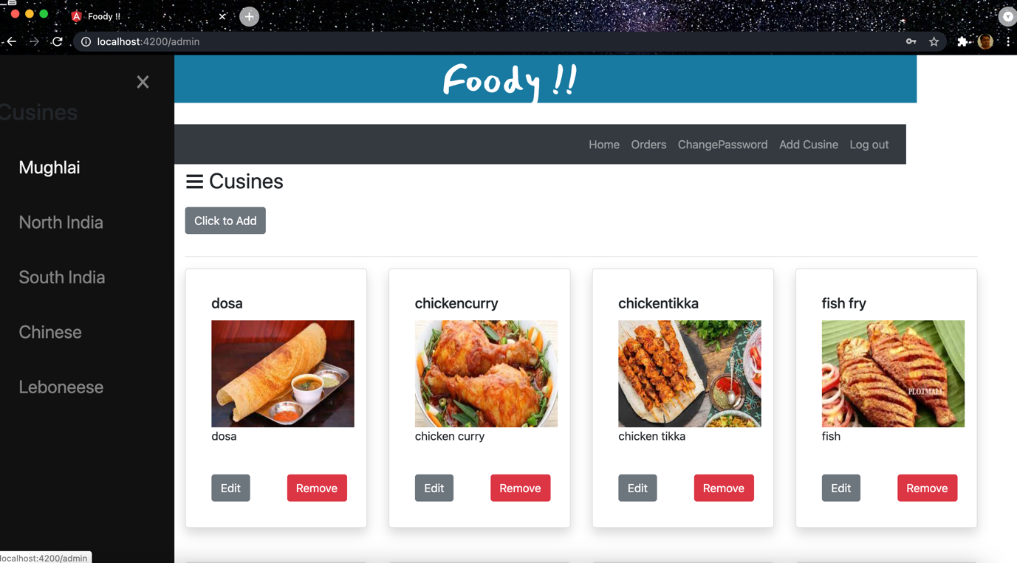

REGISTER END USER:

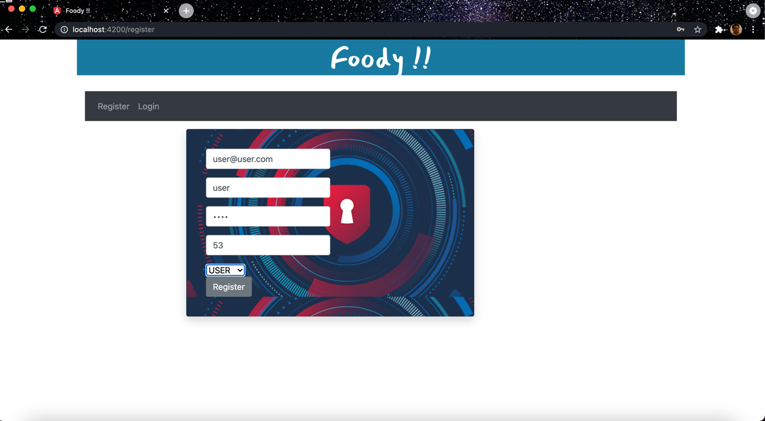

LOGIN END USER:

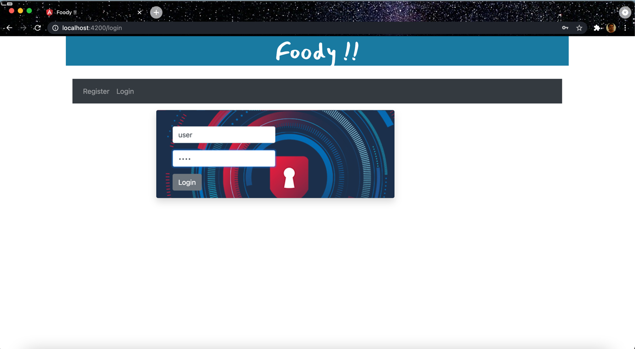

LANDING PAGE FOR END USER:

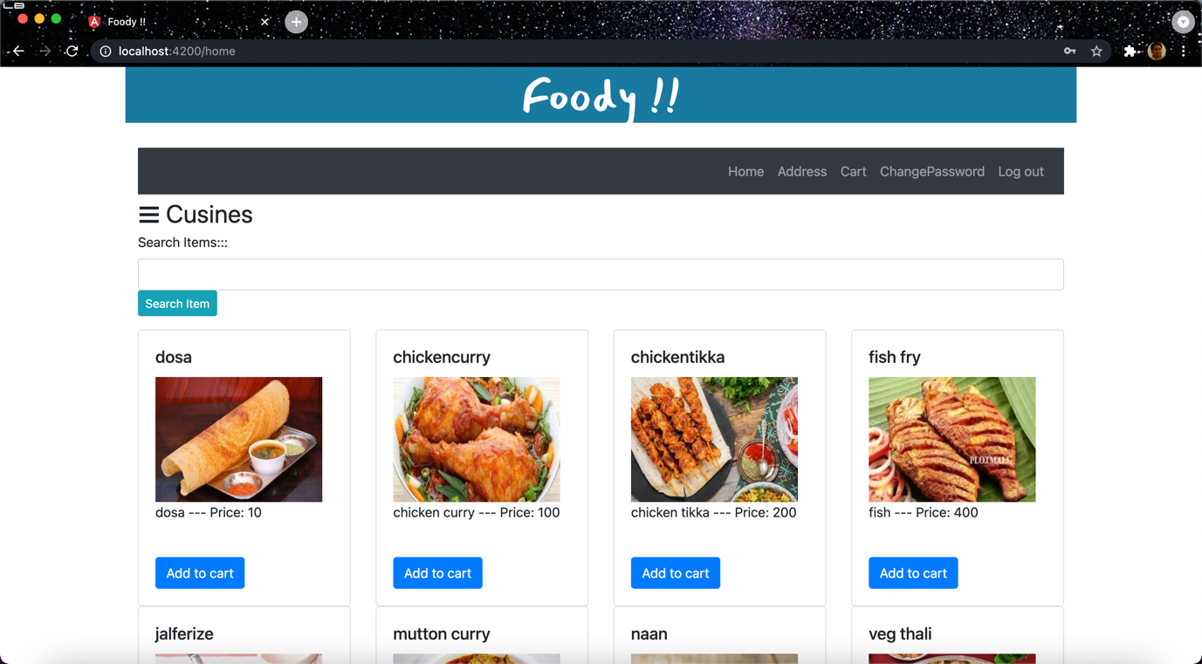

LEFT MENU FOR END USER:

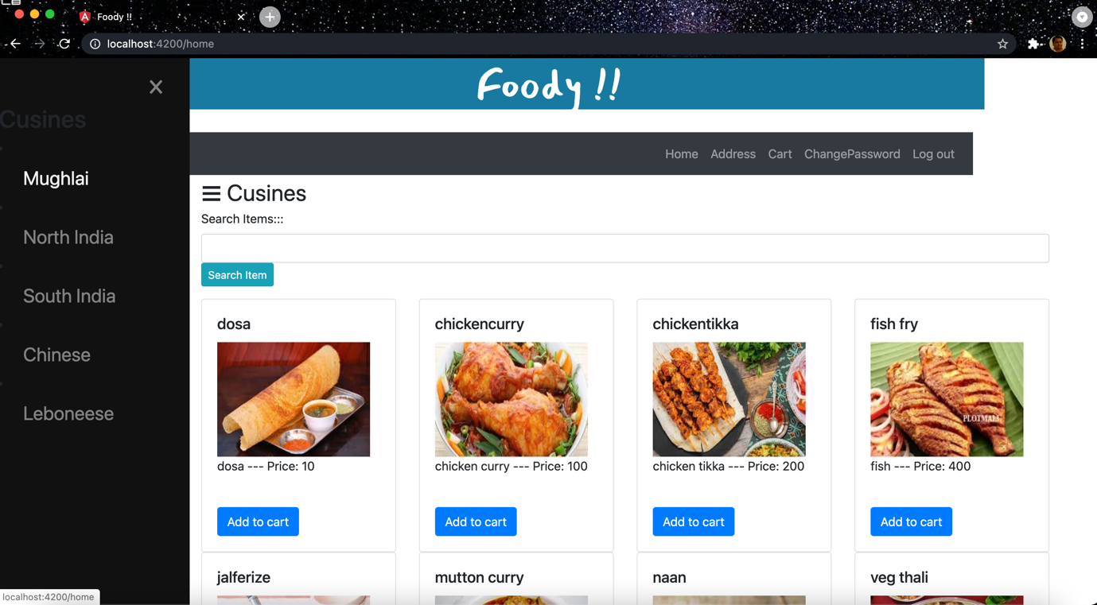

SEARCH WITH KEYWORDS END USER:

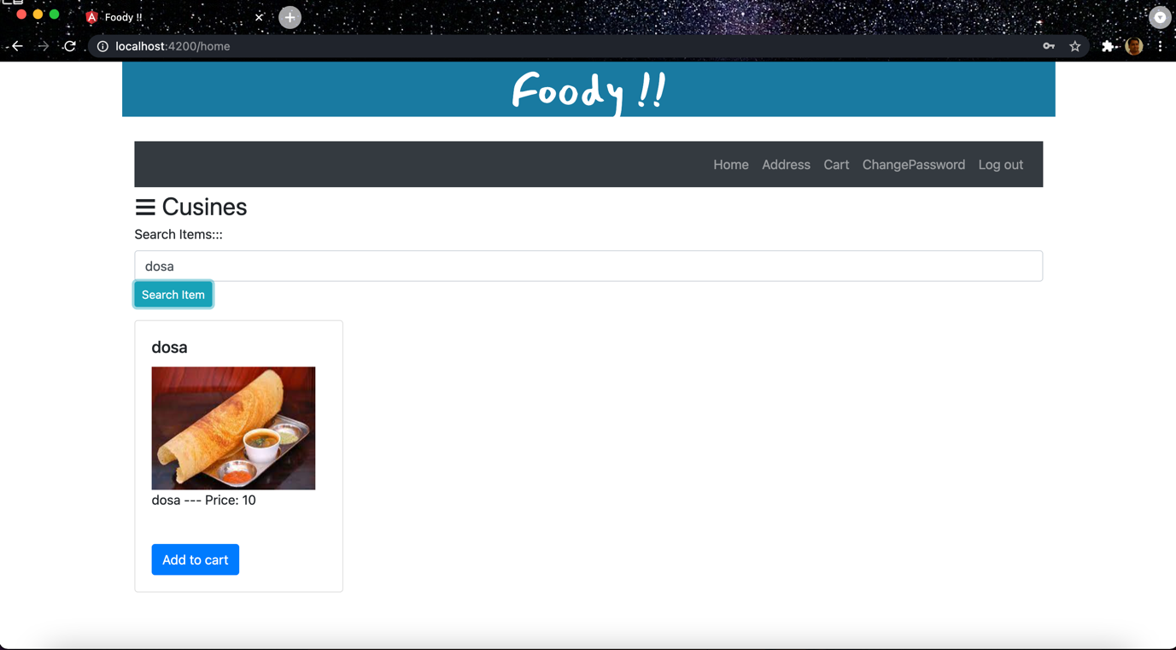

SEARCH BY CUISINE LEFT MENU END USER

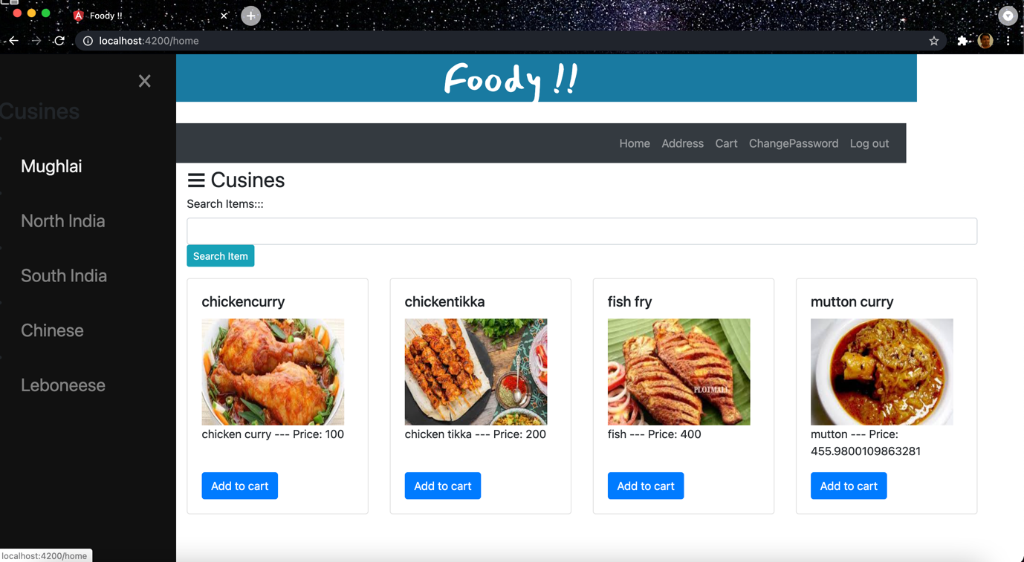

ADD ADDRESS END USER

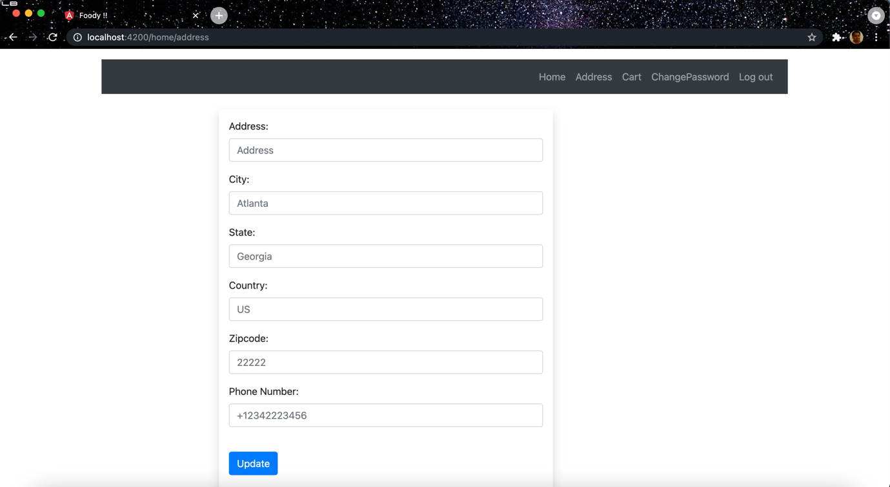

ADD ITEM TO CART:

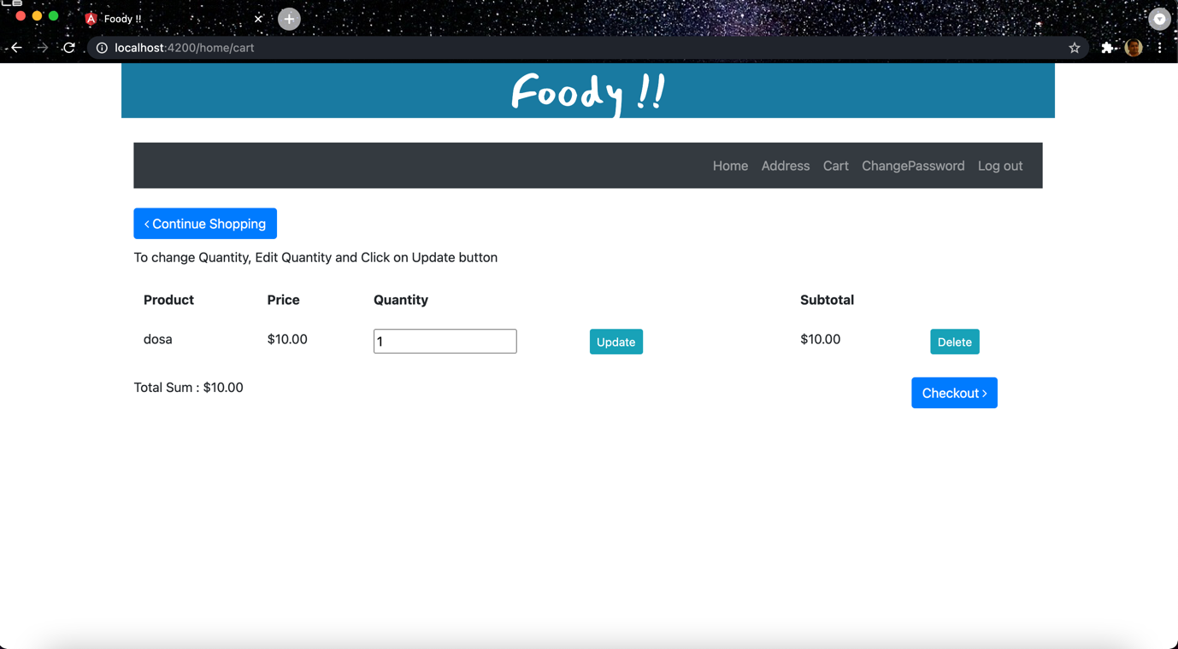

CHANGE PASSWORD END USER:

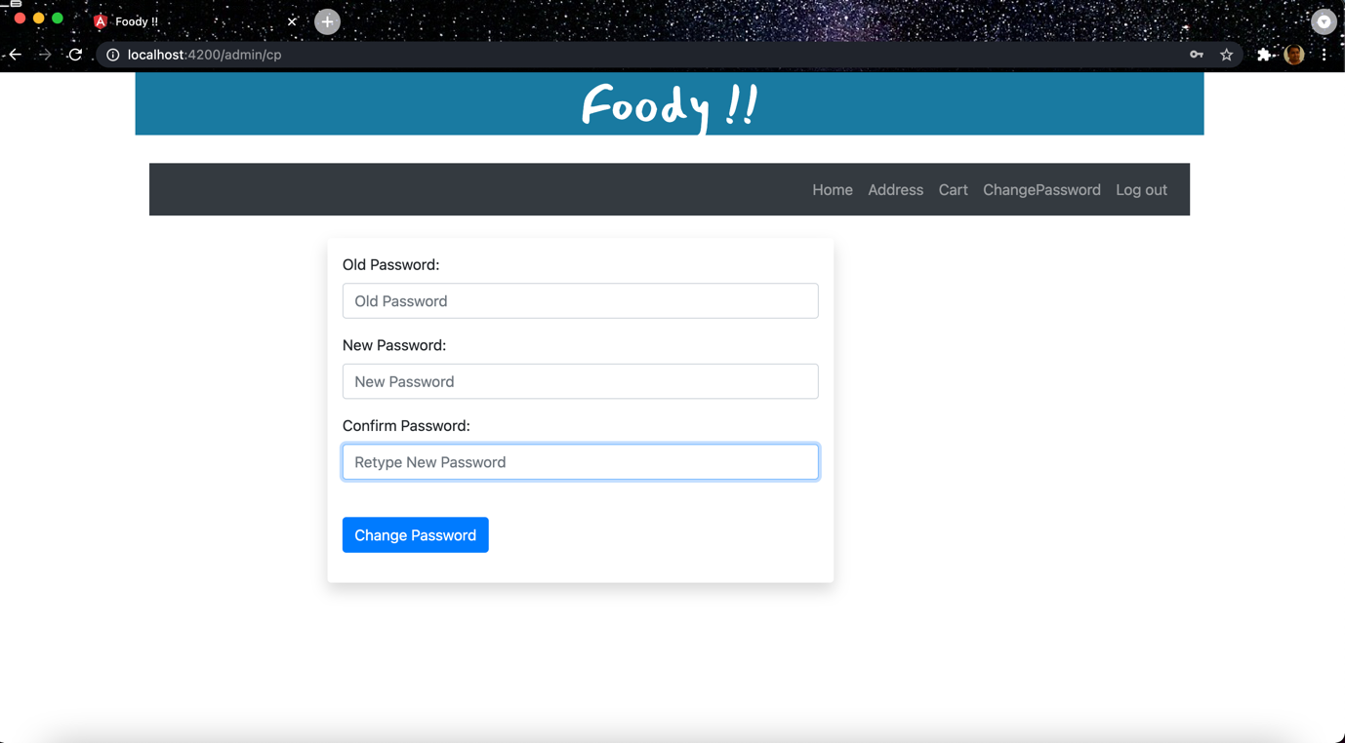

=====================================================================  
  
USING DOCKER TO RUN THE APP ON LOCALHOST:  
*##### NOTE: NEEDS DOCKER SERVER RUNNING ON THE HOST #####*

GET INTO THE PROJECT DIRECTORY.

$ cd capstone-project

BUILD THE DOCKER IMAGE WITH BELOW COMMAND:  
$ docker build . -t foody:latest  
  
RUN THE DOCKER IMAGE ON LOCALHOST  
  
$ docker run -p80:80 -p8087:8087 foody:latest  
  
ACCESS THE APP AT BELOW URL IN BROWSER:  
  
URL: http://localhost/  
  
=================================================================================  
RUN THE APP ON LOCALHOST WITH BASH COMMANDS: (MAC/LINUX)

~/capstone-project$ cd backend-app

~/capstone-project/backend-app$ mvn install -DskipTests

THIS WILL RUN THE BACKEND SPRING BOOT SERVICES

~/capstone-project/backend-app $ mvn spring-boot run

ACCESS THE APP ON :

<http://localhost:8087>

=================================================================================

~/capstone-project$ cd front-end-app

~/capstone-project/front-end-app$ npm install

THIS WILL RUN THE FRONTEND WEBSITE

~/capstone-project/backend-app $ ng serve

ACCESS THE APP ON:

<http://localhost:4200>

CI/CD PIPELINE AUTOMATION – JEKINS AND AWS

AWS EC2 CONSOLE

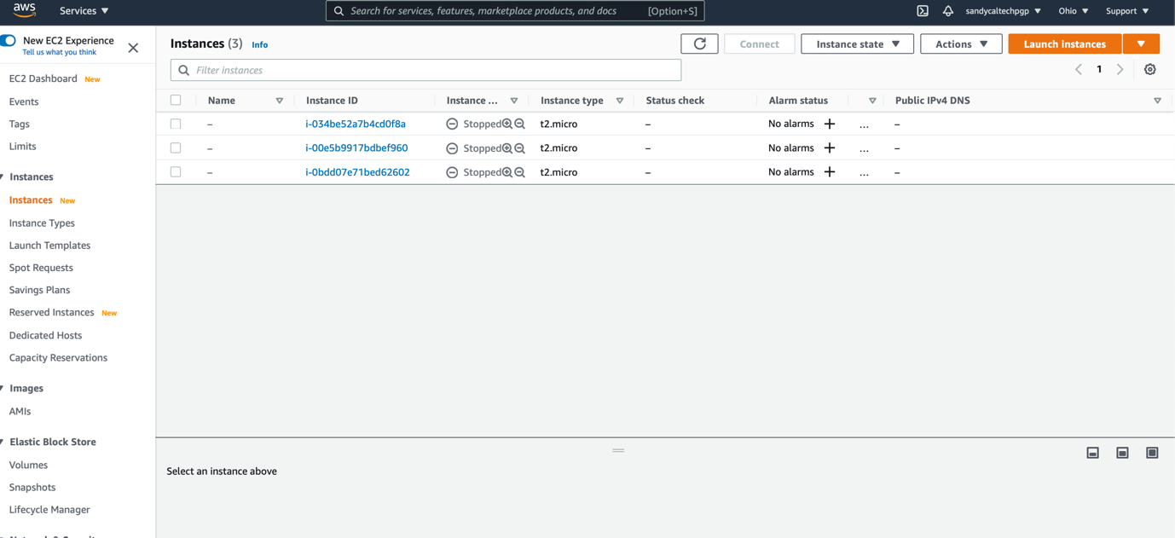

INSTALL AND START JENKINS ON EC2

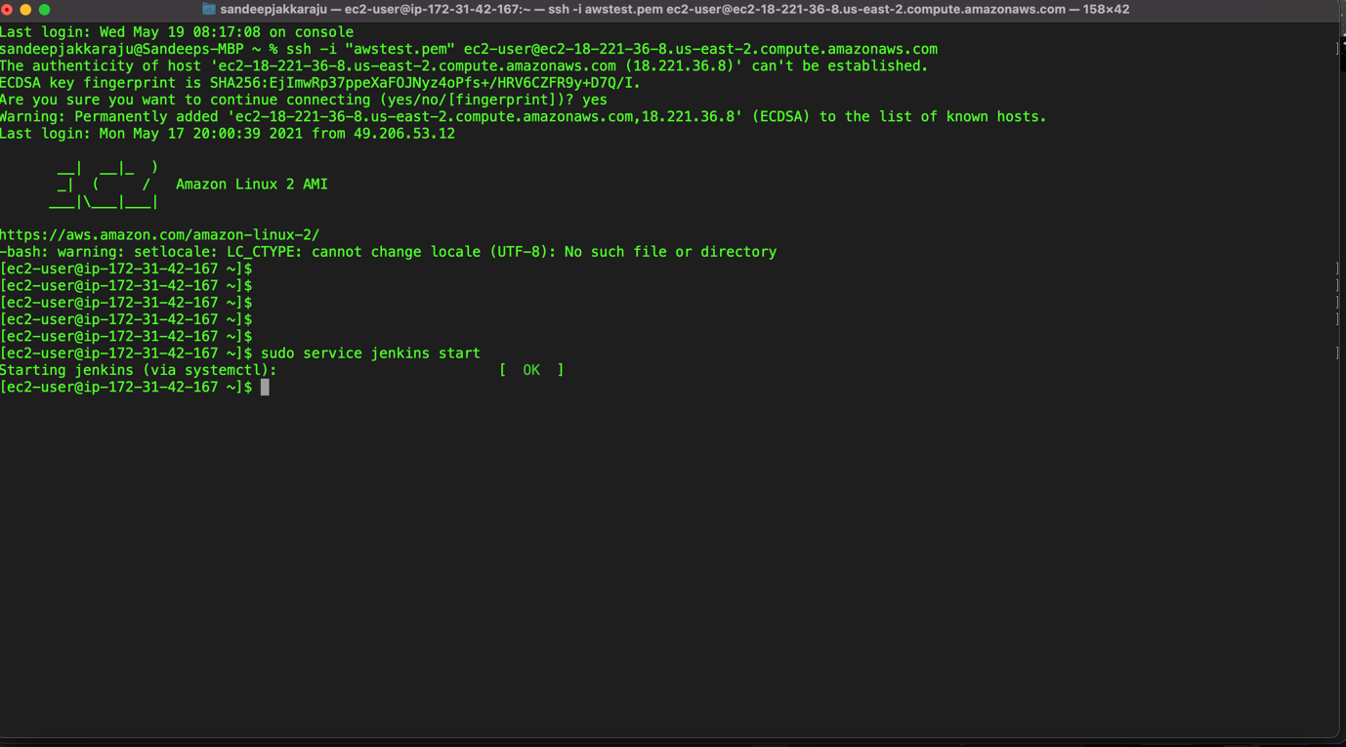

LOGIN TO JENKINS:

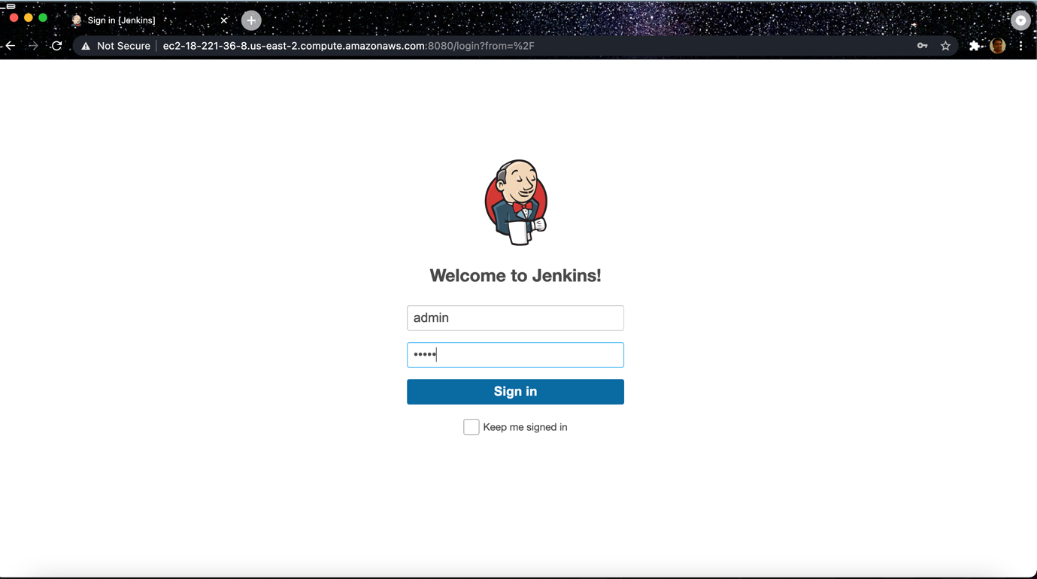

Configure the JENKINS FREE STYLE PROJECT

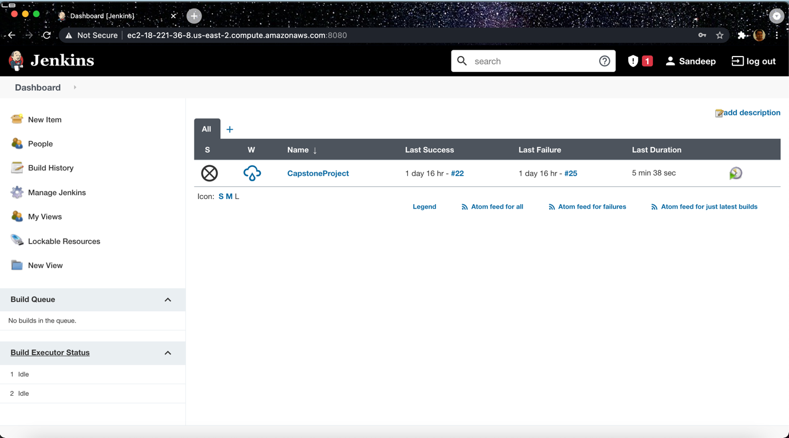

JENKINS PROJECT CONFIGURATION: using docker

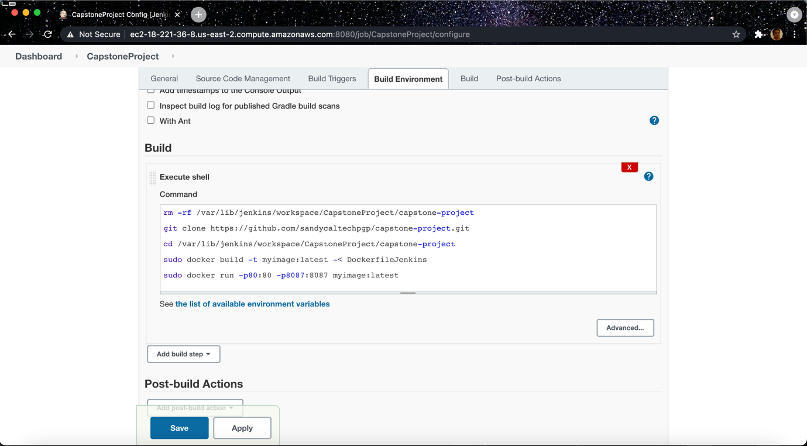

START DOCKER SERVER ON EC2 INSTANCE

NOTE:: PLEASE HAVE MORE DISK SPACE IN THE INSTANCE FOR DOCKER TO RUN.

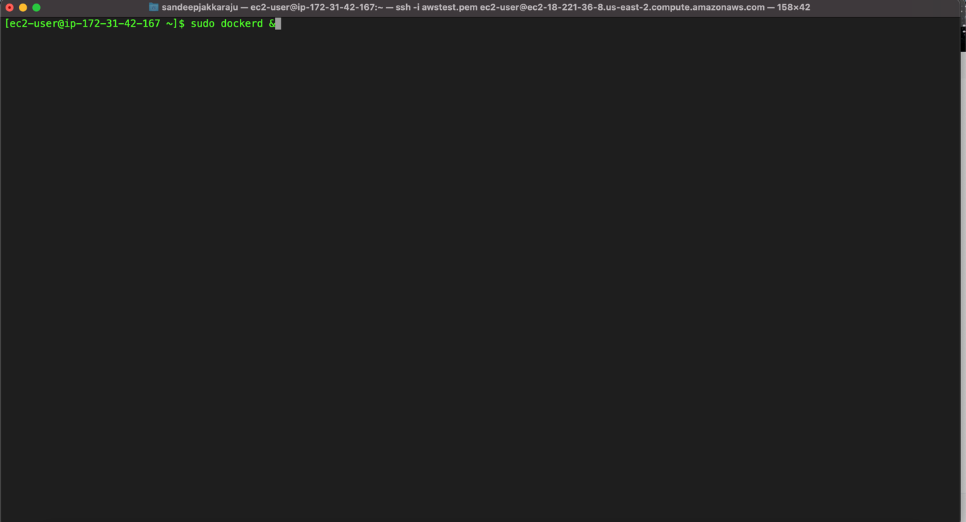

START RDS – MYSQL

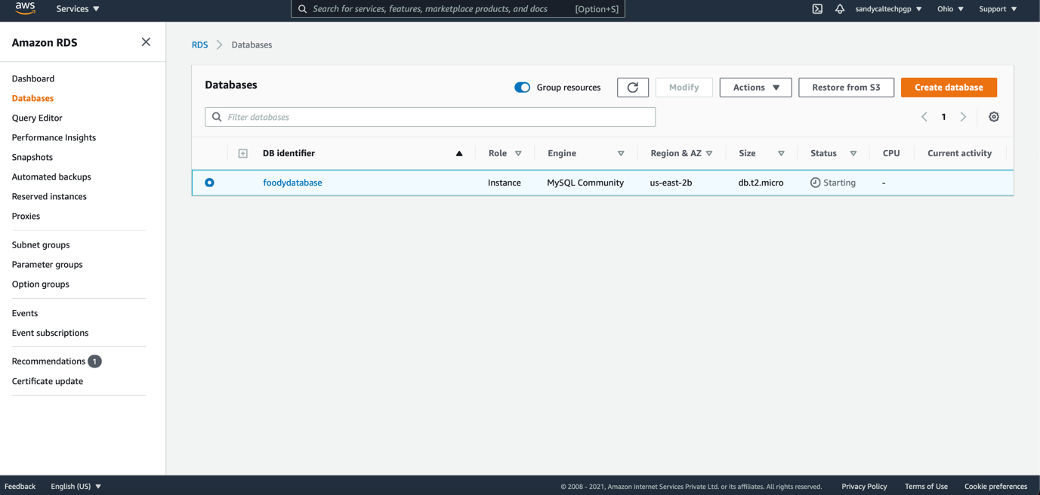

**----THE END---**